How to create and run Spark application in Windows PC

Author: Rao Weijin Date:2016-1-15

Envirionment:

Win10;

Eclipse Luna

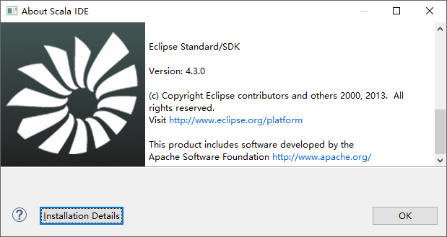

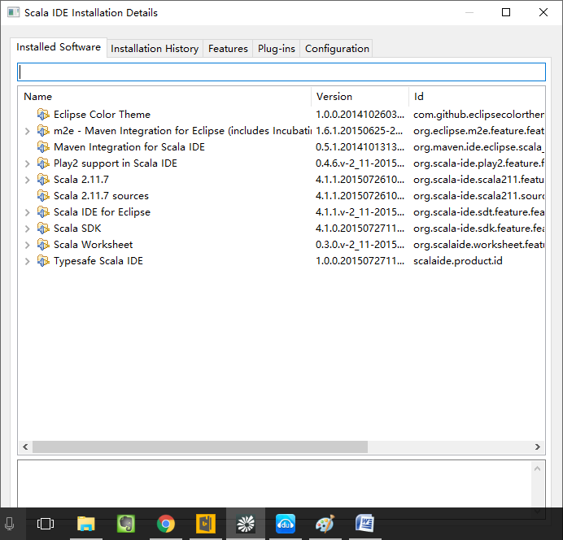

1. Create MavenProject

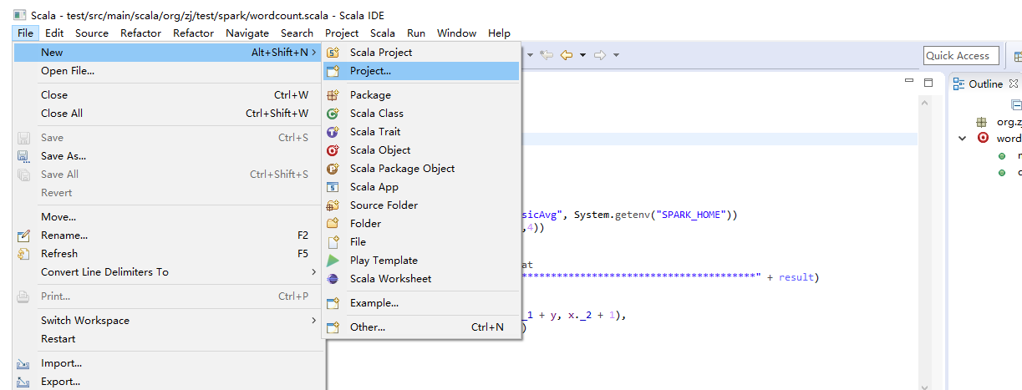

1. Maven Project

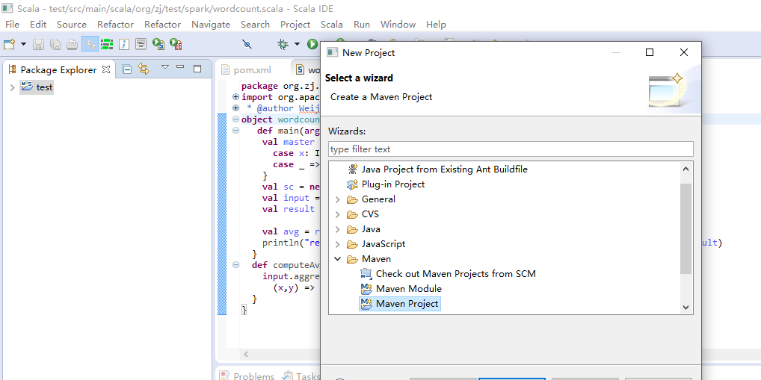

1. Please choose the option of Create a simple project

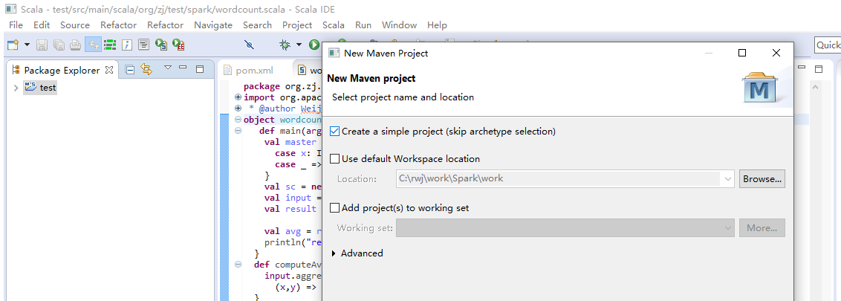

1. Input groupId and artifactId in the dialogue

<project xmlns="http://maven.apache.org/POM/4.0.0" xmlns:xsi="http://www.w3.org/2001/XMLSchema-instance" xsi:schemaLocation="http://maven.apache.org/POM/4.0.0 http://maven.apache.org/xsd/maven-4.0.0.xsd">

<modelVersion>4.0.0</modelVersion>

<groupId>**org.spark.zj**</groupId>

<artifactId>**demo**</artifactId>

<version>0.0.1-SNAPSHOT</version>

1. Edit pom.xml,编写完成后需要save code.在save过程中，eclipse会自动编译xml file

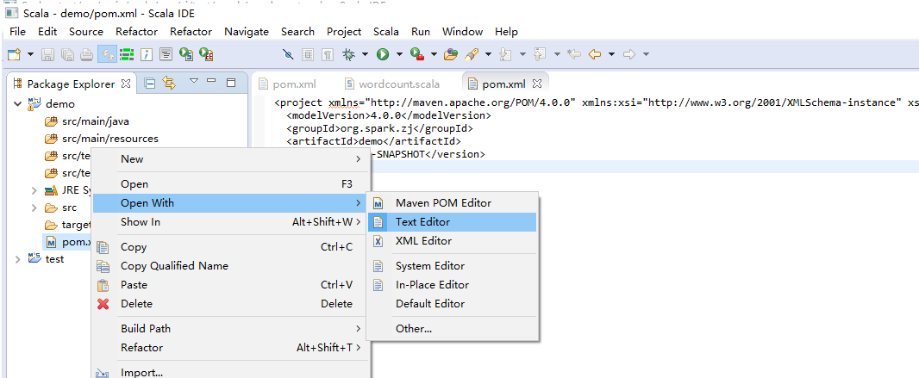

<project xmlns="http://maven.apache.org/POM/4.0.0" xmlns:xsi="http://www.w3.org/2001/XMLSchema-instance" xsi:schemaLocation="http://maven.apache.org/POM/4.0.0 http://maven.apache.org/xsd/maven-4.0.0.xsd">

<modelVersion>4.0.0</modelVersion>

<groupId>org.zj</groupId>

<artifactId>test</artifactId>

<version>0.0.1-SNAPSHOT</version>

<!-- library dependencies -->

**<dependencies>**

**<dependency>**

**<groupId>org.apache.spark</groupId>**

**<artifactId>spark-core_2.11</artifactId>**

**//2.11似乎是scala compiler的version; 1.5.1似乎是spark version**

**<version>1.5.1</version>**

**</dependency>**

**</dependencies>**

</project>

1. configure scala compiler version

选择demo，点击鼠标右键查看properties。确保scala版本和xml文件中内容一致

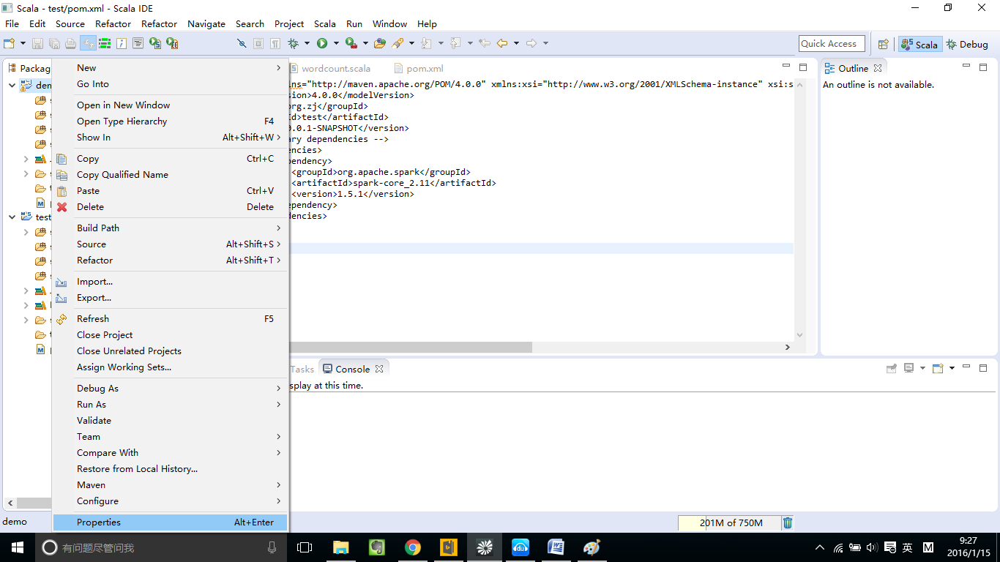

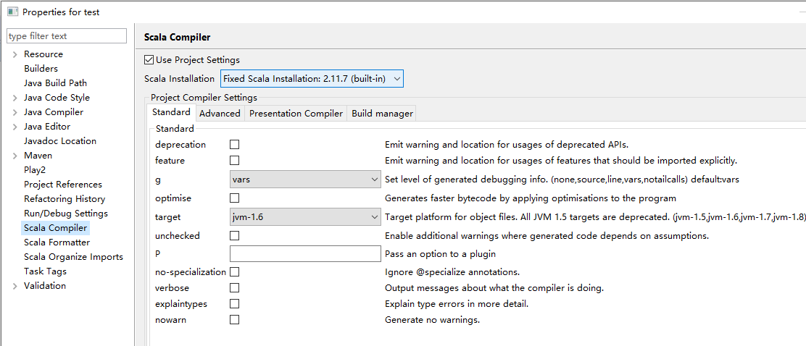

1. add scala nature

这一步很重要，否则后面无法增加scala file

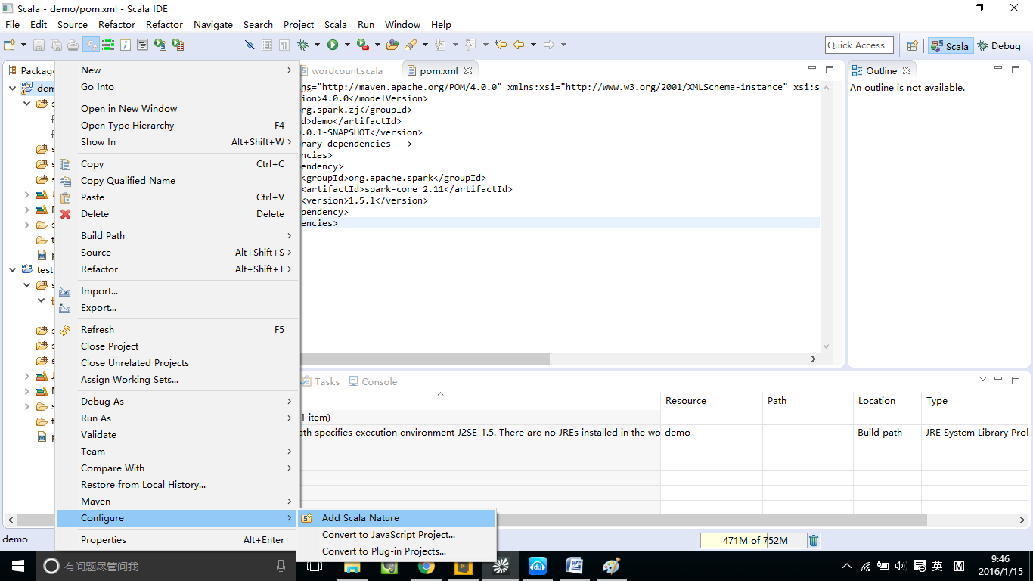

1. 修改目录结构，将java改成scala

分别选择src/main/java和src/test/java。点击鼠标右键分别执行下面的操作

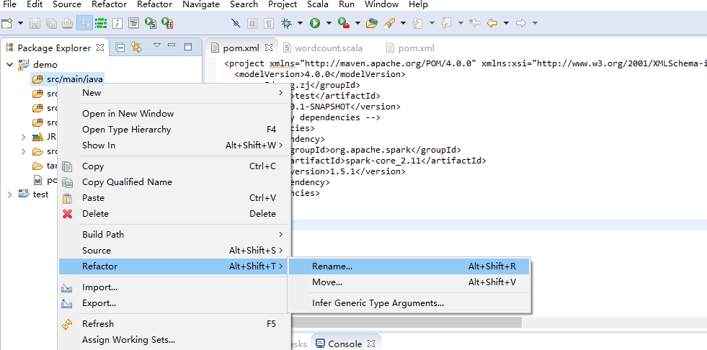

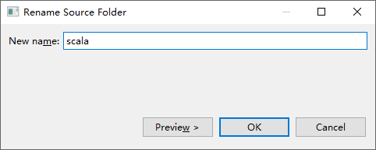

1. Create Packate

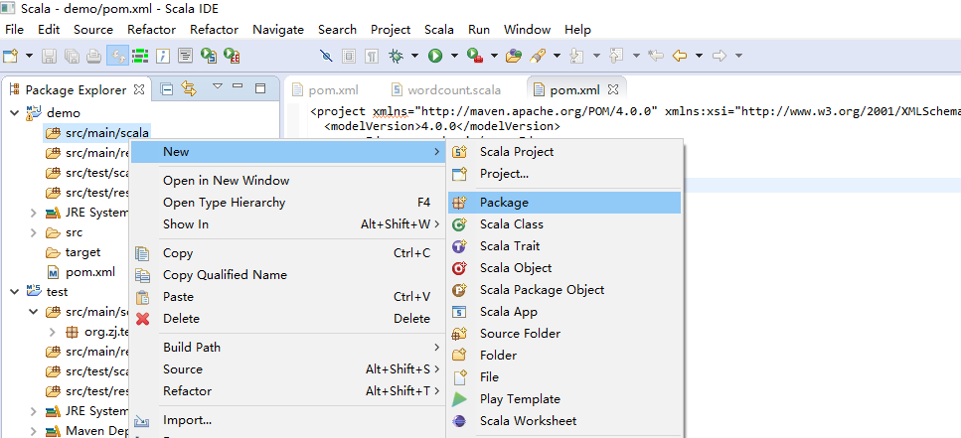

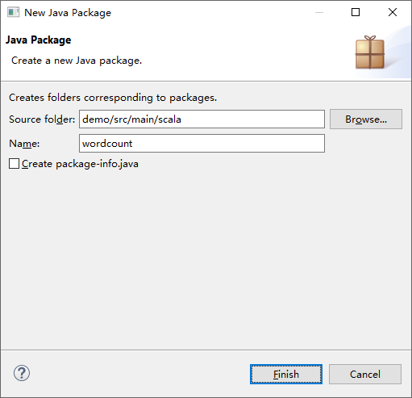

1. 增加scala object

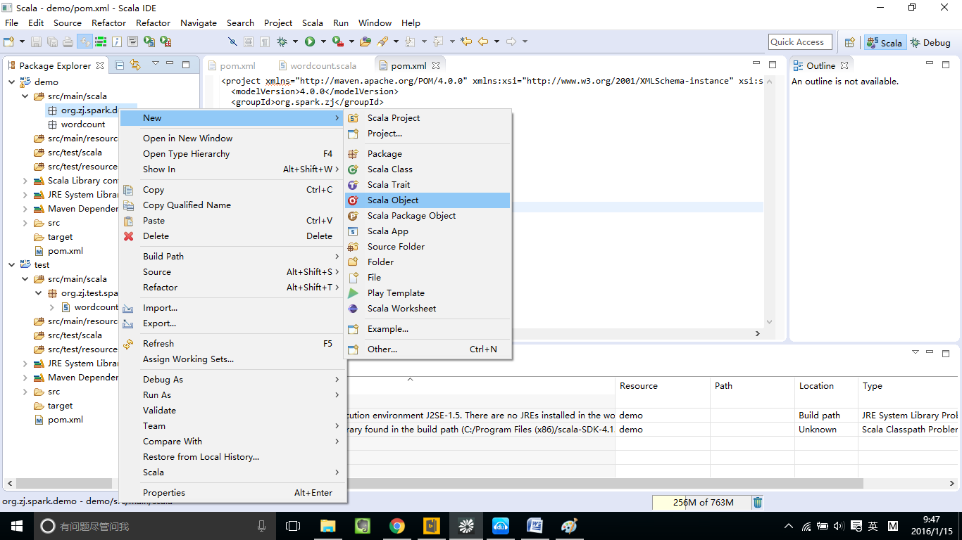

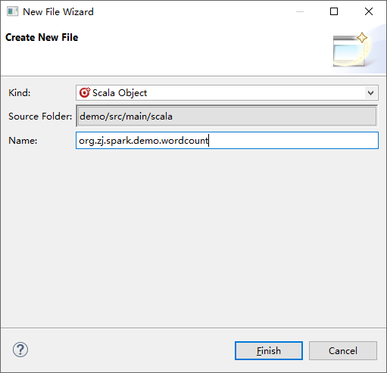

1. 编写spark code

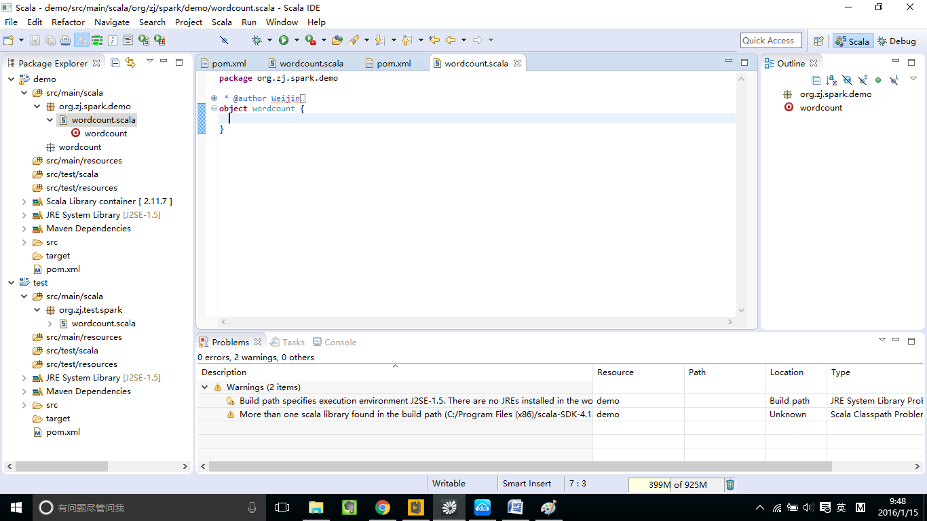

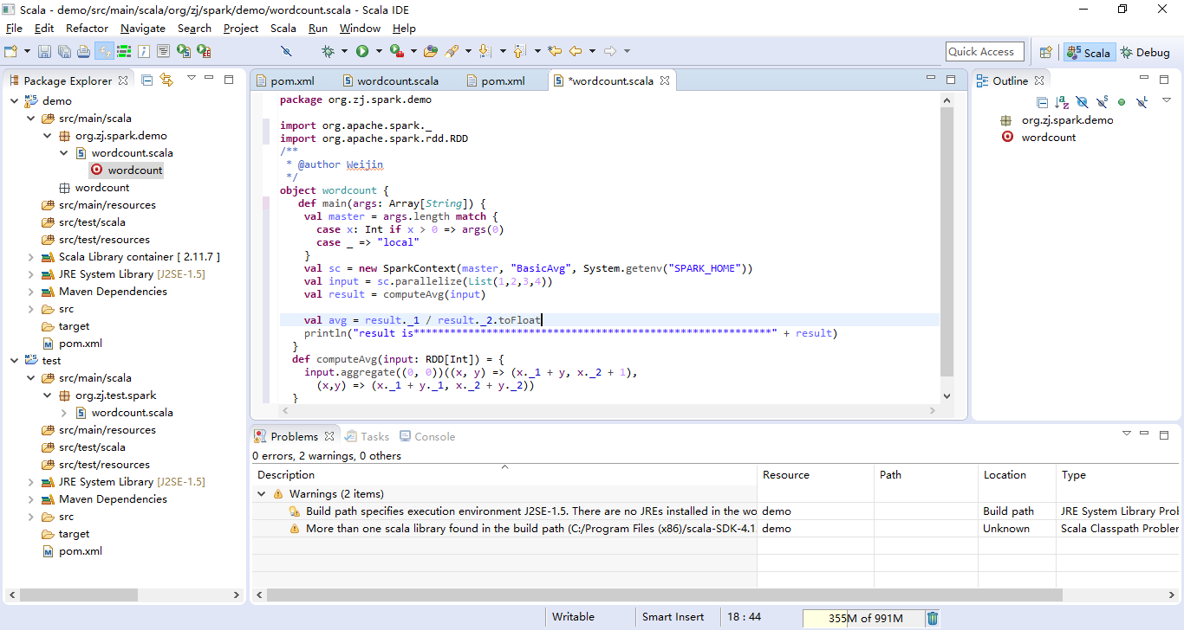

1. 运行spark code

这个需要联网操作，eclipse自动从服务器上download对应库

